|  |
| --- |
| PS2Win |
| Weekly Report |
| Keep Your Time |

|  |
| --- |
| Filipe Brandão  14-04-2013 |

**Team Members:**

Carla Machado

David João

Filipe Brandão

João Girão

João Martins

Mário Oliveira

Rui Ganhoto

**Week 7**, 8th of April to 15th of April

Content

1. Week Activities 1

1.1. Work Executed 1

1.2. Work Analyses 1

1.3. Achievements 1

2. Impediments 2

3. Plans For Next Week 2

4. Progress 2

4.1. Earned value and/or Gantt Image 2

4.2. Effort by task 3

4.3. Individual effort 3

5. Individual log 4

**Images**

Figure 1: Earned Value 2

Figure 2: Week effort by task type 3

Figure 3: Week effort by team member 3

**Tables**

Table 1: List of Contributors ii

Table 2: Version history ii

Table 3: Log of individual effort 4

|  |  |  |  |
| --- | --- | --- | --- |
| **Authors and Contributors** | | | |
| **Date** | **Name** | **Contacts** | **Contribution** |
| 14-04-2013 | Filipe Brandão | a21180276@alunos.isec.pt | Author |
| 15-04-2013 | Mário Oliveira | a21170292@alunos.isec.pt | Contributor |
| 15-04-2013 | Rui Ganhoto | a21170262@alunos.isec.pt | Contributor |
| 15-04-2013 | Carla Machado | a21170460@alunos.isec.pt | Contributor |
|  |  |  |  |
|  |  |  |  |
|  |  |  |  |

Table 1: List of Contributors

|  |  |  |  |  |  |
| --- | --- | --- | --- | --- | --- |
| **Revision History** | | | | | |
| **Date** | **Description** | **Author** | **Version** | **Approvers** | **State** |
| 14-04-2013 | Creation of first draft | Filipe Brandão | 0.1 |  | Ready for Revision |
| 15-04-2013 | Document reviewed | Mário Oliveira | 0.1 |  | Ready for Revision |
| 15-04-2013 | Changing State | Filipe Brandão | 0.1 |  | Ready for Approval |
| 15-04-2013 | Document Approved |  | 0.1 | Rui Ganhoto | Ready for Approval |
| 15-04-2013 | Approved |  | 0.1 | Carla Machado |  |
|  |  |  |  |  |  |
|  |  |  |  |  |  |
|  |  |  |  |  |  |
|  |  |  |  |  |  |
|  |  |  |  |  |  |
|  |  |  |  |  |  |

Table 2: Version history

# Week Activities

# Work Executed

* Brainstorming session
* Use Case definition and mockups
* Started Requirements Definition
* Started Tests Plan
* Changed and approved V&S
* Approved Quality Plan
* Changed and approved Software Development Plan
* Changes to Project Assessment And Control Process
* Changes to Verification & Validation Process
* Changes to Coding Standards
* Unconformities List created
* Earned Value prepared

# Work Analyses

This week’s work was dedicated to the Requirements Analysis phase that started with a meeting for a brainstorming session. In this meeting the new features requested by the stakeholders during the KickOff Meeting and other functionalities were discussed.

The Use Case Definition task is finished.The effort hours were less than planned, leaving some time for rework (if needed).

While the Requirements were being defined many questions arose leaving the idea that there are still details to be discussed.

Because the team made an effort to meet early in the week (and not only on Saturday), we were able to advance the start of the Tests Planning task that was planned only for next week. This way, we could already prepare some test cases to cover the defined requirements.

The team gave all their attention to the Requirement Analysis tasks and lost some focus in the tasks that were still to be finished from last week (updating, reviewing and approving documents).

# Achievements

* Use case definition is finished (although it’s possible to do some rework)
* Quality Plan and Project Plan are now approved.

# Impediments

* Members allocated to the Requirements Definition found that there are still many details to be clarified.
* Members allocated to the Tests Planning had doubts about what is a “test case” and how it should cover a requirement.

# Plans For Next Week

* Approve all the documentation regarding processes.
* Continue Requirements Definition and Acceptance Tests Planning.
* Risk Meeting at the end of the week.

# Progress

# Earned value and/or Gantt Image

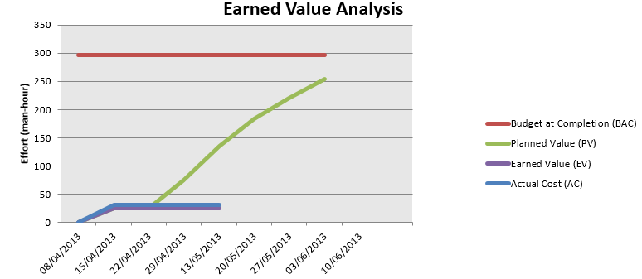

Figure 1: Earned Value

Planned Value = 26h

Earned Value = 26h

Actual Cost = 31,8h

# Effort by task

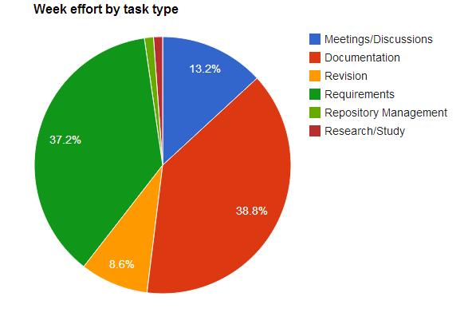

Figure 2: Week effort by task type

# Individual effort

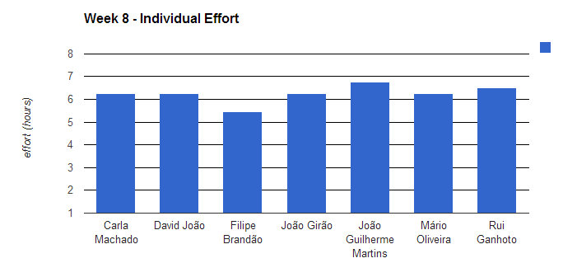

Figure 3: Week effort by team member

|  |  |
| --- | --- |
| **Name** | **Effort(hours)** |
| Carla Machado | 6.25 |
| David João | 6.25 |
| Filipe Brandão | 5.45 |
| João Girão | 6.25 |
| João Guilherme Martins | 6.75 |
| Mário Oliveira | 6.25 |
| Rui Ganhoto | 6.5 |

Table 3: Log of individual effort

# Individual log

**Carla Machado - Tasks done:**

* Brainstorming - 0.75h
* Review minute - 0.25h
* Writing of use cases - 3.75h
* Approving Documents (Minutes & Vision and Scope) - 0.5h
* Use Case/Requirements Discussions - 0.25h
* Changes in the Quality Plan - 0.25h
* Writing of use cases, Traceability BR-UC - 0.5h

**David João - Tasks done:**

* Brainstorming - 0.75h
* Tiny update to minute - 0.25h
* Layout definition and writing of some acceptance tests - 5h
* Study how to do Acceptance tests in EA - 0.25h

**Filipe Brandão - Tasks done:**

* Brainstorming - 0.75h
* Business Rules and Mockups - 2.75h
* Updated SDP - 0.5h
* Approved Vision and Scope and Quality Plan - 0.5h
* Updated Dashboard - 0.25h
* Use Case/Requirements Discussions - 0.25h
* Weekly Report - 0.45h

**João Girão - Tasks done:**

* Brainstorming - 0.75h
* Change Verification and Validation Process (Ready for approval) - 0.5h
* Prepare earned value - 1.75h
* Use Case/Requirements Discussions - 0.25h
* Requirements Definitions – 3h

**João Martins – Tasks done:**

* BrainStorming - 0.75h
* Agenda - 0.75h
* Acceptance tests­­ – 5h
* Study how to do Acceptance tests in EA - 0.25h

**Mário Oliveira - Tasks done:**

* Revision weekly report - Week6 - 0.25h
* Brainstorming - 0.75h
* Update repository - 0.25h
* Revision Vision and Scope document - 0.25h
* Revision coding standards document - 0.75h
* Revision quality plan document - 0.5h
* Revision software development plan document - 0.5h
* Requirements definition – 3h

**Rui Ganhoto - Tasks done:**

* Brainstorming - 0.75h
* Meeting Minutes Summary – 1h
* Use Case Definition – 2.5h
* Coding Standards Corrections -1.5h
* Use Case Priorities and Complexity Discussion - 0.25h
* Quality Plan Approval - 0.25h
* Mockups Analysis and Review - 0.25h